Enhancing agricultural harvester machinery through strategic component sourcing

02 December 2025

In agriculture, where seasonal windows dictate productivity, the reliability of harvesters and balers is critical. Machinery failure during peak harvesting times can lead to costly delays, crop loss, and increased labor expenses. For original equipment manufacturers (OEMs), this puts a premium on designing equipment that combines durability, serviceability and operational efficiency. Increasingly, they are achieving these goals by sourcing more mechanical components, such as couplings, chains, bearings, and brakes, from a single, multi-brand supplier with deep technical expertise.

Traditionally, OEMs sourced mechanical components from various vendors, each with its own specifications, lead times, and engineering standards. However, there is growing momentum toward working with fewer suppliers that offer broader product portfolios. True multi-discipline component manufacturers can provide power transmission systems, motion control products, and load-handling solutions under one umbrella.

This approach reduces procurement complexity, improves component compatibility, and simplifies inventory and service parts management. It also opens the door to co-engineered systems where chains, couplings, and bearings are not just individually optimized but designed to work together for greater overall efficiency and reliability.

Couplings in harvesters

Couplings are an essential part of any harvester, whether used in grain, corn, or root crop machines. Their job is to transmit rotational power between components while absorbing shock loads and compensating for misalignment. In agricultural settings, where dust, debris, and vibration are constant challenges, high-performance couplings help protect drivetrains from premature wear and failure.

Component manufacturers with experience in the agricultural sector have developed specialized couplings that meet these demands. Features like torsional flexibility, vibration damping, and corrosion-resistant materials ensure these couplings can endure the harsh conditions of harvesting fields while extending machine life and reducing maintenance requirements.

Chain solutions for round balers

Among the most heavily stressed components in agricultural machinery are the chains in round balers. These chains must endure high loads and repeated shock cycles, often in dirty, abrasive environments. Over time, conventional chains may stretch or wear out prematurely, leading to inconsistent bale formation or unexpected breakdowns.

To address this, experienced component suppliers have developed heavy-duty agricultural chains specifically designed for round balers. One such innovation includes high-strength steel construction, precision-manufactured pins and bushings, and enhanced lubrication retention. These features help maintain chain integrity over time, minimize elongation, and ensure reliable operation throughout the baling season.

Bearings and brakes

Though less visible, bearings and brakes play equally critical roles in agricultural machinery. High-performance bearings must support rotating shafts under heavy loads, resist contamination from dust and moisture, as well as operate in wide temperature ranges. Agricultural bearings often incorporate advanced sealing systems and corrosion-resistant coatings to extend service life in the field.

Braking systems, too, must be tailored to the rigors of field work. Whether used for stopping machinery safely or holding position on slopes, agricultural brakes require consistent performance in variable conditions. Experienced component designers offer brake systems that combine high stopping power with low maintenance, contributing to both safety and machine uptime.

Collaborating with OEMs for better designs

One of the most significant advantages of working with a multi-brand component supplier is the ability to co-develop systems with OEM engineering teams. This collaboration begins early in the design process and includes application-specific analysis, computer modeling, prototype development and field testing.

Such partnerships allow OEMs to optimize machinery performance from the outset, reducing the risk of costly redesigns or service issues post-launch. It also enables more compact, efficient designs and faster time-to-market for new equipment models.

Benefiting farmers and operators

For the end user, typically a farmer or contractor, the benefits of integrated component design are practical and immediate. Machines built with coordinated power transmission systems tend to experience fewer failures, are easier to maintain, and offer more consistent performance across the seasons.

Using components developed and tested together also improves parts availability and service simplicity. When fewer suppliers are involved, it’s easier to source compatible replacements and receive consistent technical support.

A case in point: Regal Rexnord

A prominent example of this approach is offered by Regal Rexnord, a global manufacturer that supplies couplings, chains, bearings, and brakes across multiple brands. It has developed the Rexnord HS-series chain, which is used by several manufacturers in round balers, and a wide range of Centa® couplings designed for combines, foragers and other harvesters. Warner Electric™ is renowned for heavy-duty electromagnetic brakes that feature in harvesting machinery from many brands.

The benefits of working with Regal Rexnord also extend to parts ordering and deliveries. The large stock availability, even for brand-specific parts, ensures production schedules are maintained as well as enhanced logistics and after-sales support for end users.

These solutions exemplify the kind of specialized engineering that supports both OEM innovation and field durability. By offering broad product coverage and application expertise, suppliers like Regal Rexnord help bridge the gap between equipment design and real-world performance.

Image captions:

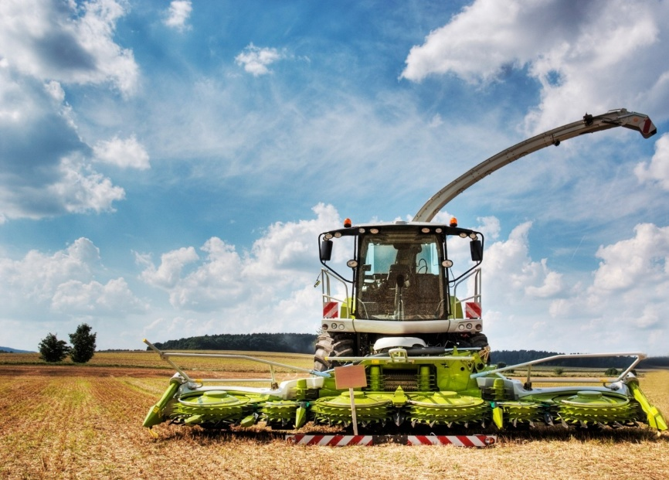
Image 1: Harvesters are complex machines that require robust and durable components to ensure reliable operation.

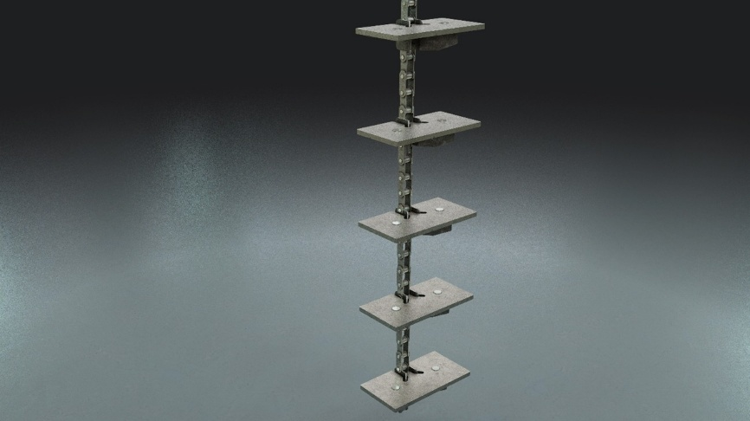
Image 2: Specialist elevator chains can be specified with a variety of attachments depending on the crop.

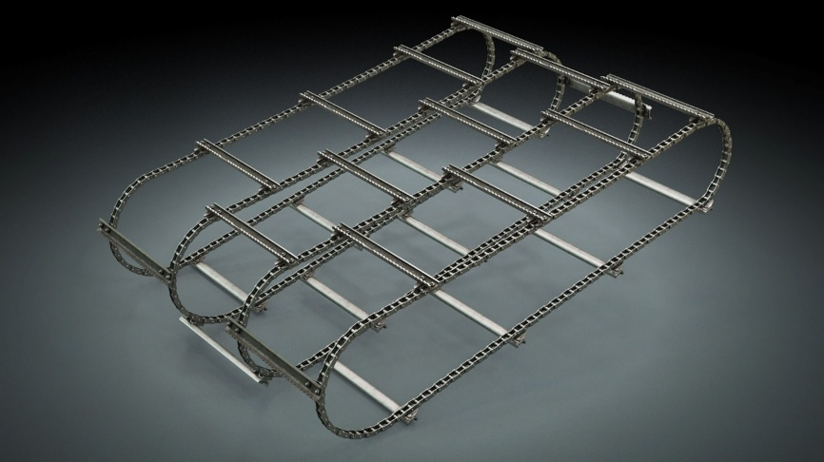
Image 3: Combine elevator chains are designed to operate in a challenging environment.

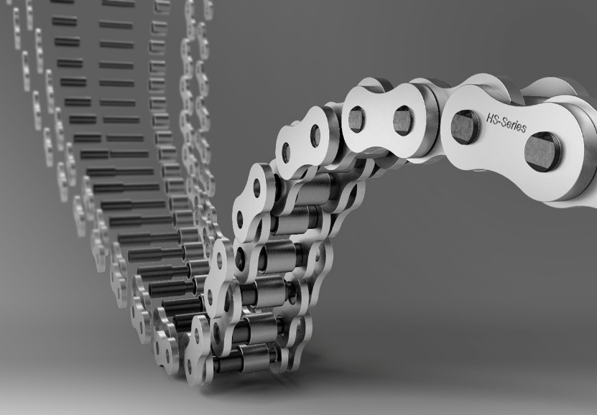
Image 4: Rexnord HS-Series chain is engineered specifically for high-stress baler applications.

The image(s) distributed with this press release are for Editorial use only and are subject to copyright. The image(s) may only be used to accompany the press release mentioned here, no other use is permitted.

About Regal Rexnord

Regal Rexnord's 30,000 associates around the world help create a better tomorrow by providing sustainable solutions that power, transmit and control motion. The Company's electric motors and air moving subsystems provide the power to create motion. A portfolio of highly engineered power transmission components and subsystems efficiently transmits motion to power industrial applications. The Company's automation offering, comprised of controllers, drives, precision motors, and actuators, controls motion in applications ranging from factory automation to precision tools used in surgical applications.

The Company's end markets benefit from meaningful secular demand tailwinds, and include discrete automation, food & beverage, aerospace, medical, data center, energy, residential and commercial buildings, general industrial, and metals and mining.

Regal Rexnord is comprised of three operating segments: Industrial Powertrain Solutions, Power Efficiency Solutions, and Automation & Motion Control. Regal Rexnord is headquartered in Milwaukee, Wisconsin and has manufacturing, sales and service facilities worldwide. For more information, including a copy of our Sustainability Report, visit RegalRexnord.com.

Press Contact:
Regal Rexnord Corporation: Jenna Zembrowski, PR and Content Lead
Email: mediarelations@regalrexnord.com
Web: RegalRexnord.com

PR Agency:
DMA Europa Ltd : Zoe Taylor, Account Manager
Progress House, Great Western Avenue, Worcester, WR5 1AQ, UK
Tel.: +44 (0) 1905 917477
Email: zoe.taylor@markettechgroup.com
Web: news.dmaeuropa.com

