Regal Rexnord showcases wind turbine solutions at HUSUM WIND 2025

21 August 2025

Regal Rexnord will return to HUSUM WIND 2025 with a powerful message for wind energy professionals: long-term reliability, improved health and safety, and real-world efficiency gains delivered by genuine parts, expert knowledge, and a hands-on approach.

Visitors can meet the team in Hall 3, Stand 3C33, as well as outside at Stand 0F10, where the company’s Roadshow Truck will host interactive demonstrations of advanced wind service tools.

With decades of experience across its well-known brands – including Svendborg Brakes™, Stromag™, Warner Electric™, Tollok™, CENTA™, Jaure™, and Ameridrives™ - Regal Rexnord offers a comprehensive range of braking and drivetrain solutions for wind turbine OEMs, operators, and service providers. Whether contributing key components for new equipment or supplying the spare parts, specialized tools and retrofit services needed to keep assets operating, the company delivers practical support for wind turbine lifecycle management.

Supporting uptime through expertise

The wind energy sector is seeing rapid growth in both the size and age of its installed fleet. With more turbines reaching maturity, operators are facing increasing challenges around part availability, service, and safety.

Regal Rexnord helps solve these challenges with certified, approved turbine specific spare parts, experienced technicians, and advanced troubleshooting tools. These allow operators to keep their assets online and generating power longer, maximizing return on investment.

“Preventive maintenance isn’t just cost-effective, it’s vital for ensuring long-term turbine performance,” says Dierk Sternberg, Global Aftermarket Manager Wind. “We support our customers by providing approved parts, specialized tools, and expert guidance to help them stay ahead of potential issues. And when damage does occur, we respond quickly with reliable solutions that minimize downtime. It’s essential to recognize the critical role each component plays in the overall turbine operation and to always use parts that meet original specifications.”

Hands-on demonstrations in the Roadshow Truck

One of the highlights of the Regal Rexnord showcase will be the presence of its Roadshow Truck just outside the main halls.

The truck will feature a full-size working display of the Lifting & Installation Tool (LBS 120) for Yaw Brakes (e.g. BSAB 120) – a solution that allows for faster, safer brake replacement with preassembled turbine-ready units. Visitors can test the tools in person and experience how it helps cut turbine downtime in half, allowing units to come back online days earlier than they would with conventional tools. Also on display will be the full-size demo of the yaw disc resurfacing tool (DRTGen.2), which allows on-site machining of damaged brake discs. This helps avoid costly crane work and disassembly, while delivering real cost savings and uptime gains. Before-and-after samples and friction material options will be available for visitors to explore.

Reliable parts, safe systems, and local support

As cost pressures grow across the wind sector, Regal Rexnord will show why cutting corners on spare parts can cost more in the long run. At HUSUM WIND, the team will demonstrate how certified and approved components deliver lasting value, ensuring safety, maintaining turbine integrity, and reducing unplanned downtime. For critical systems like yaw and rotor brakes, using certified parts helps preserve performance, prevent premature wear, and protect against invalidated warranties or insurance claims.

Alongside this, Regal Rexnord will showcase its expanding portfolio of data-driven maintenance and IIoT-enabled solutions. These tools give operators site-specific insights into braking patterns, vibration levels, and wind behaviour, allowing them to transform data into actionable maintenance strategies. By shifting from reactive to predictive servicing, operators can extend component life, reduce technician call-outs, and plan maintenance around actual turbine conditions.

Together, these technologies help wind operators lower total cost of ownership, improve safety, and boost long-term turbine availability backed by the expertise and quality assurance of Regal Rexnord.

Experience you can trust

Regal Rexnord’s presence in the wind sector is built on more than 40 years of experience, with a legacy that stretches back to the very start of commercial wind energy. Today, the company assists a global fleet of more than 200,000 turbines, with components still in service after 20 or even 30 years. This legacy of reliability continues to guide their approach to product development, customer service, and field support.

Whether you're an OEM seeking integrated drivetrain solutions, a service provider, utility company or a wind farm owner looking to enhance uptime and technician safety, Regal Rexnord invites you to visit Hall 3, Stand 3C33 and Stand 0F10 – where they will be exhibiting as Svendborg Brakes, Regal Rexnord – to explore the company’s full wind energy portfolio.

Image captions:


Image 1: Regal Rexnord offers a comprehensive range of braking and drivetrain solutions for wind turbine OEMs, operators, and service providers.

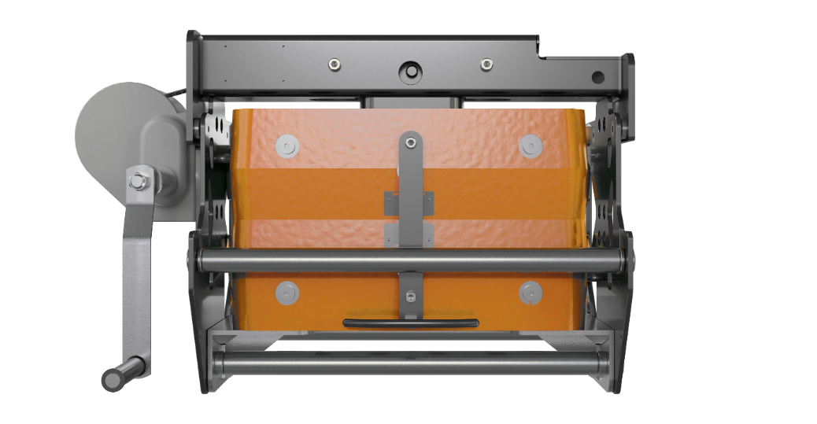
Image 1: Regal Rexnord’s Lifting & Installation Tool (LBS 120) allows for faster, safer brake replacement with preassembled turbine-ready units.

The image(s) distributed with this press release are for Editorial use only and are subject to copyright. The image(s) may only be used to accompany the press release mentioned here, no other use is permitted.

About Regal Rexnord

Regal Rexnord's 30,000 associates around the world help create a better tomorrow by providing sustainable solutions that power, transmit and control motion. The Company's electric motors and air moving subsystems provide the power to create motion. A portfolio of highly engineered power transmission components and subsystems efficiently transmits motion to power industrial applications. The Company's automation offering, comprised of controllers, drives, precision motors, and actuators, controls motion in applications ranging from factory automation to precision tools used in surgical applications.

The Company's end markets benefit from meaningful secular demand tailwinds, and include discrete automation, food & beverage, aerospace, medical, data center, energy, residential and commercial buildings, general industrial, and metals and mining.

Regal Rexnord is comprised of three operating segments: Industrial Powertrain Solutions, Power Efficiency Solutions, and Automation & Motion Control. Regal Rexnord is headquartered in Milwaukee, Wisconsin and has manufacturing, sales and service facilities worldwide. For more information, including a copy of our Sustainability Report, visit RegalRexnord.com.

Press contact:
Regal Rexnord Corporation
Britt Lightbody
Marketing Coordinator
Tel: +45 52 140 255
britt.lightbody@regalrexnord.com

PR agency:
DMA Europa
Zoe Taylor
Account Manager
Progress House, Great Western Avenue, Worcester, WR5 1AQ, UK
Tel.: +44 (0) 1905 917477
zoe.taylor@markettechgroup.com
news.dmaeuropa.com

